**TensorFlow Lite Tutorial**

**Tensorflow Model to Lite Version**

**Simple Code to Convert Save3d Model to tflite model**

**Simple Code to convert keras model to tflite model**

**Dependencies of Tensorflow**

dependencies{

implementation 'org.tensorflow:tensorflow-lite:0.0.0-nightly'

}

android{

apptOptions{

noCompress "tflite"

}

}

**Performance Inference**

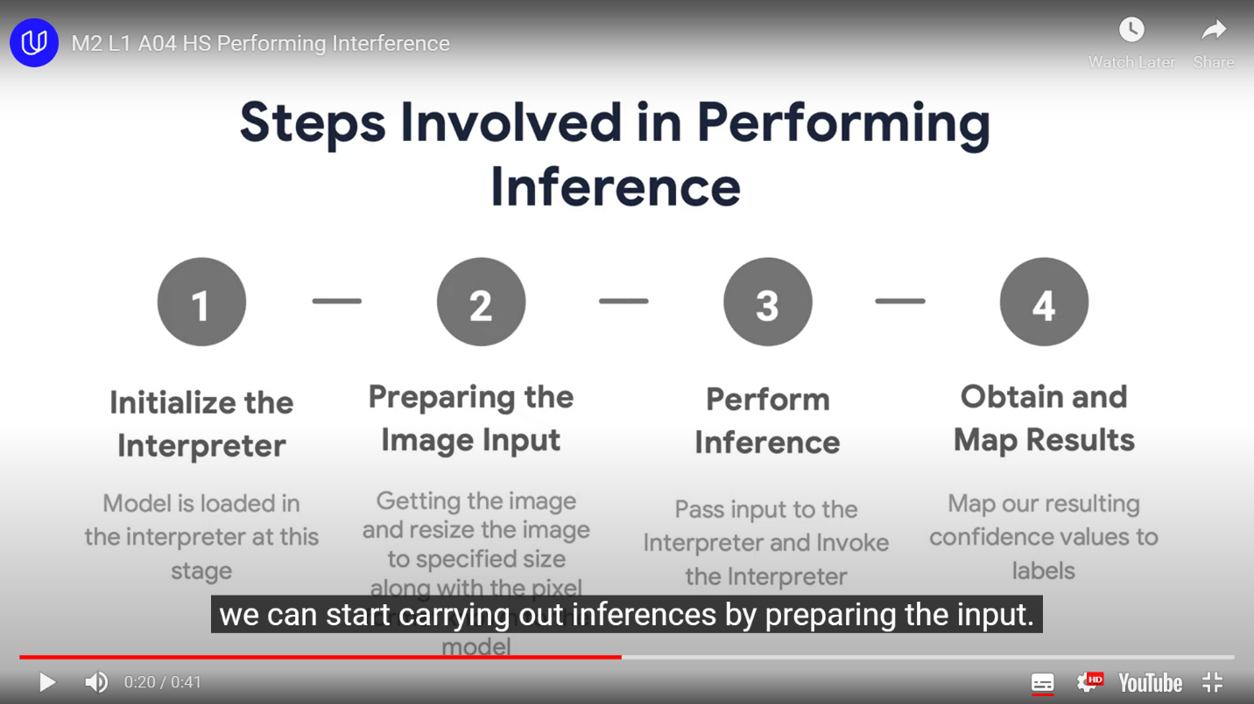

**Architecture To be followed while Developing Tensorflow Android app using**

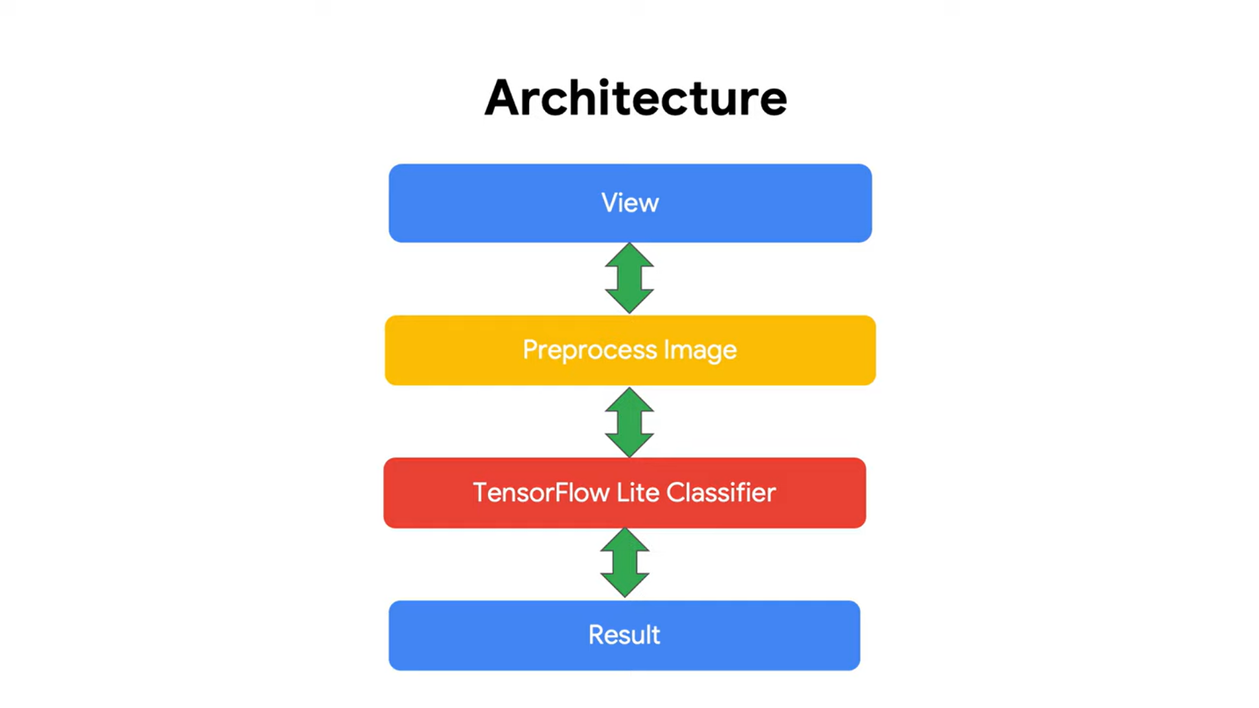

Where the **view** is responsible for taking input from the view and handover it to for pre-processing.

**Pre-process Image** is responsible for preprocessing the image taken from the view.

**TensorFlow Classifier** is responsible for Passing the pre-processed image to Interpreter for classification.

Finally in **Result**, we take the Prediction from the Classifier and prints output.